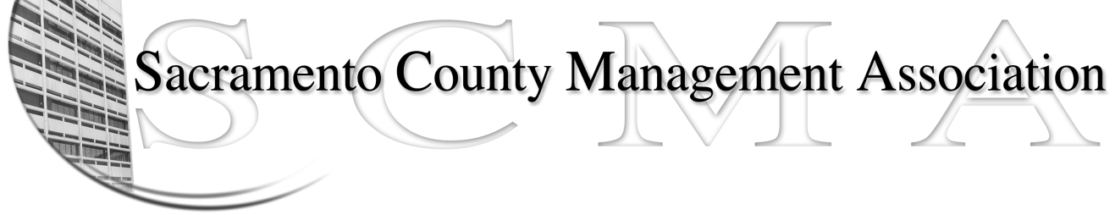

Kelsey Johnson, President Diana Ruiz, Vice-President
Jan Holm, Treasurer Nancy Gust, Secretary
Frances Worth, Board Member Darcy Moehring, Board Member
Pamela Harris, Board Member Cathy Girton, Board Member
Stephen Wallach, Board Member Kathy Bryan, Board Member
Bruce Coker, Board Member Vacant, Board Member

SCMA Board of Director’s Agenda
January 2, 2013 - 3:00 P.M.
9616 Micron Avenue, Suite 900 (Back of the complex)

- Introductions

- Review and approve the minutes from the December 5, 2012 Board of Director’s Meeting

- Treasurer’s Report – Jan

- Committee Reports
  - Association Meeting – Jan
  - Bylaws – Sue
  - Elections – Kelsey/Roberta
  - Website – Craig
  - Membership – Darcy
  - Discipline – Kathy
  - Meet & Confer – Diana

- Correspondence

- Old Business
  - LTD – Board of Director Ins Updates

- New Business

- Adjournment

- Closed Session

