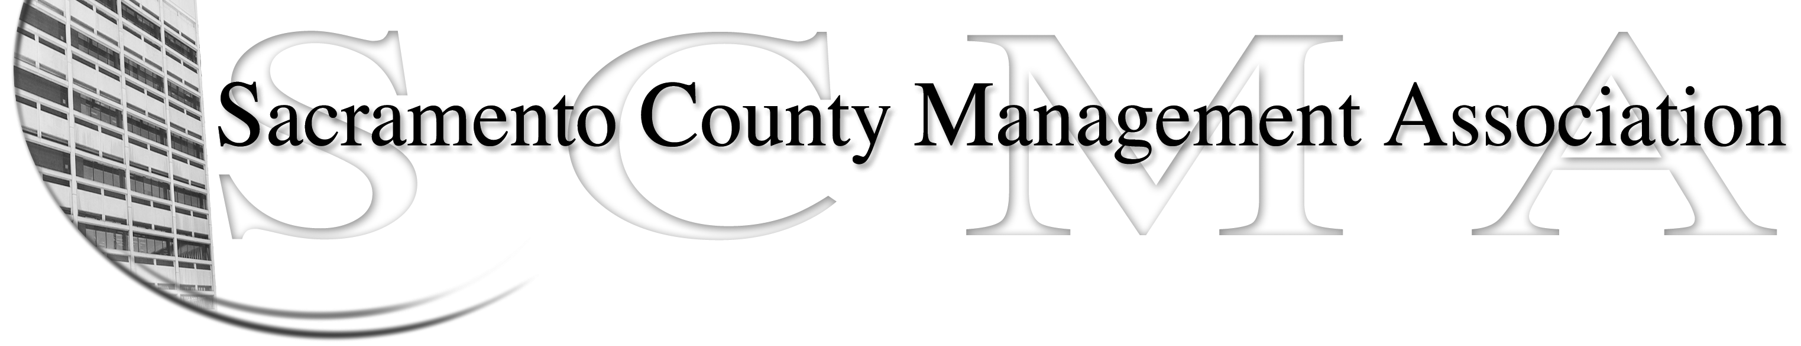

Sue Elliott, President Nancy Gust, Board Member
Mike Guiver, Vice President Craig Rader, Board Member
RoseMary Vaske, Secretary Brad Buyse, Board Member
Forrest Williams, Treasurer Robert Nelson, Board Member
Phil Fischbach, Past President

September 26, 2009

Dear SCMA Member,

As you are aware, we are facing some very challenging times. Whether at home or at work, we cannot escape the economic realities and the impacts they are having on us and our peers both personally and professionally.

In April, the CEO recommended, and the Board of Supervisors approved, a County mandate that managers take 14 furlough days and eliminate the 2.9% COLA for Fiscal Year 2009-10. Because SCMA does not have the authority to negotiate, the CEO and Labor Relations’ recommendations were adopted by the Board. The CEO and Labor Relations determined managers needed to set the example with hopes that unions would follow; this did not occur. Additionally, the vacation over max benefit was permanently eliminated for managers and the Board has since raised questions about the cost of two management benefits, Sick Leave Cash Out and the 401A Deferred Compensation Plan. These two benefits are still at risk. The SCMA Board has addressed the Board of Supervisors on all of these occasions and continues to monitor issues affecting managers.

During our Spring Comedy Luncheon, SCMA took an informal Straw Poll and 46% of the attendees were interested in pursuing representation by a Recognized Employee Organization (REO). As a result, SCMA formed a subcommittee and retained independent legal counsel. Enclosed is some very important information about this process. Please review it carefully. The flowchart describes the REO process and the enclosed signature card would allow this process to begin. If enough signatures are collected, information sharing sessions will take place which would lead to an official ballot vote in early 2010. That vote will allow ALL County managers to decide whether or not they wish to be represented by an REO.

The sub-committee met with Terry Schutten and Steve Keil on Friday, September 25th, to inform them of this action and SCMA has also sent notices to the Board of Supervisors. This topic will be the main focus during SCMA’s 2009 Fall Business Luncheon and attendance is limited to managers within 050. Legal counsel will also be there to address your questions and concerns.

In addition to the REO issue, the SCMA Board has proposed revisions to the bylaws. The bylaws have been posted to the SCMA website since September 15, 2009 at www.scmamgt.org. The current bylaws require a ballot be mailed to all members to vote on the revisions. Enclosed, on blue paper, is the ballot. Please vote and return per the instructions.

We look forward to seeing you at the luncheon on October 15, 2009.

Sincerely,

2009 SCMA Board of Directors

